System Requirements Statement (SRS) –

Gym Management System

Created by : Sanket Ghaytadak, Ajay Kesale, Bhushan Ahire, Sharad Shinde

Date :26-07-2023

1. Introduction 3

2. Functional Requirements 4

2.1 User Module 4

2.2 Trainer Module 9

2.3 Admin Module 11

2.4 Use Case Diagram 15

# Introduction

* **Document Purpose :**

The web based “Gym Management System” project is an attempt to simulate basic concepts of gym management system. The system enables the member to do the things such as search for workout-plans, diet plans and choose them based on the details of the plans. The system provides a facility that provides details about gym contact details with locations, Gallery, Programs and Blogs. But if user wants to book plan then he/she must login into his/her account.

* **Scope of the project :**

This project traverses a lot of areas ranging from business concept to computing field, and required to perform several researches to be able to achieve the project objectives.

The area covers include:

* Gym Management System is being done, process involved and opportunity that exist for improvement.
* JAVA Spring Boot Technology used for the development of the application.
* General new user, members, trainer and admin will be able to use the system effectively.
* **Overview of the Project :**

The purpose of this document is to identify unambiguously the user requirements and clearly define both functional and non-functional requirements of Gym Management system. In addition, this document is intended to cover technical goals as well as objectives of the proposed System.

This document explains the system requirements and scope for developing Gym Management System.

Gym Management System could divide the three main parts, User part, Trainer part, Admin part.

This document describes the system requirement of the Account part.

# Functional Requirements

The Account part of Gym Management System has three modules which are divided 13 processes described as below.

|  |  |  |
| --- | --- | --- |
| **No** | **BRS requirement ID** | **Description** |
| **2.1** | **User Module** | |
| **2.1.1** | **F1** | **Account Creation Process** |
| **2.1.2** | **F2** | **Login Process** |
| **2.1.3** | **F3** | **My Order** |
| **2.1.4** | **F4** | **Book Plan** |
| **2.1.5** | **F5** | **Calculate BMI** |
| **2.1.6** | **F6** | **Search and Select Diet Plan** |
| **2.1.7** | **F7** | **Search and Select Workout Plan** |
| **2.2** | **Trainer Module** | |
| **2.2.1** | **F11** | **Login Process** |
| **2.2.2** | **F12** | **View Profile** |
| **2.2.3** | **F13** | **CRUD – Diet Plan** |
| **2.2.4** | **F14** | **CRUD – Workout Plan** |
| **2.3 Admin Module** | | |
| **2.3.1** | **F21** | **Login Process** |
| **2.3.2** | **F22** | **User List** |
| **2.3.3** | **F23** | **Membership Plan** |
| **2.3.4** | **F24** | **Add Trainer** |
| **2.3.5** | **F25** | **Add Admin** |
| **2.3.6** | **F26** | **Gym Member List** |

## User Module

* User is the member of system who wants to search for the information about Gym.
* He is also able to view the workout plan and other default plan details after registering.

### Account Creation Process

* Gym Management System compels to create the account before using it. So, Gym Management System should provide the function which makes user creates new account.
* When user creates new account, the function demands information described as below.

1. Registration

* The Registration information consists of some items described as below.

1. First Name
2. Last name
3. E-mail ID
4. Password
5. Contact Number

*All items are compulsory demanded.

* 1. First Name
* The First Name has constraints described as below.

1. Capital alphabet (A-Z)(first letter should be capital)
2. Small alphabet (a-z)(remaining letter should be small)
   1. Last Name

* The Last Name has constraints described as below.

1. Capital alphabet (A-Z)(first letter should be capital)
2. Small alphabet (a-z)(remaining letter should be small)
   1. E-mail ID

* If the Email ID correspond with not case-sensitive to other which is previously registered, the Email-ID should not be registered as an account.
  1. Password
* The Password has constraints which makes the Password consists of more than or

equal 8 and less than or equal 16 characteristics including characters described as below.

1. Numeric figure (at least one)
2. Capital alphabet (A-Z)(at least one)
3. Small alphabet (a-z)(at least one)
4. Special character (#, $, %, &, etc.) (at least one)

* The Password is masked by dummy characters. The re-entering Password is demanded.
* The Password must be encrypted in Gym Management System.
  1. Contact Number

The Contact number has constraints which makes the contact consist 10 digits.

* Registration information should be entered on one screen and Login information should be entered on another screen after confirmed registration.

### Login Process

* Gym Management System always compels user authentication before using itself except when a new account is successfully created.
* The Login information
  1. Email-ID
  2. Password
* The user authentication demands Email-ID and Password. The Email-ID and the Password should be checked in three ways.
  1. First, The Email-ID and the Password should be existed and correct.
* If The Email-ID and the Password are not equal to what the user has registered, the user authentication cannot be provided.
  1. Second, the User Type linked to the Email-ID should be "User".
* When the User Type is " User ",then user can be placed on “Users Dashboard”.
  1. Finally, Email-ID should be available.
* The Administrator can decide whether the Email-ID is available or suspended – Refer to the SRS of the Admin part.
* If User registration is timed out, user authentication is not provided for system user.
  1. Password
* The Password has constraints which makes the Password consists of more than or equal 8 and less than or equal 16 characteristics including characters described as below.

1. Numeric figure (at least one)
2. Capital alphabet (A-Z)(at least one)
3. Small alphabet (a-z)(at least one)
4. Special character (#, $, %, &, etc.) (at least one)

* The Password is masked by dummy characters. The re-entering Password is demanded.
* The Password must be encrypted in Gym Management System.
  1. The User account should alive for so long as the duration decided by Admin.
  2. Only when all the checks are successfully completed, User can be placed on respected page.
  3. The “User Dashboard” provides some of the features described as below.

1. A trigger to logout
2. A trigger to update Account
3. A trigger to My Order
4. A trigger to Workout Plan
5. A trigger to Fetch the details Diet Plan

### My Order

* When system user wants to see and add new plans then it follows following steps
  1. First, system user enters their Email-ID and Password for login
  2. Next click on MyOrder option.
  3. User can see his purchased plans

### Book Plan

When user want to Book plan then,

* Login on website
* Click on Book plan
* Then he can see various Membership plans
* He choose plan and select it.
* He pays payment
* Then plan is added to his account.

### Calculate BMI

The User can calculate BMI by using following steps

* .Click on option BMI
* Enter Height and Weight
* Then BMI is calculated.

### Search and Select Diet Plan

User can search for Diet plan as follows

* Logged in by using credentials
* Click on DietPlan
* The Diet plan Assign by trainer will display.

### Search and Select Workout Plan

User can search for Workout plan as follows

* Logged in by using credentials
* Click on WorkoutPlan
* The Diet plan Assign by trainer will display

## Trainer Module

### Login Process

* Gym Management System always compels user authentication before using itself except when a new account is successfully created.
* The Login information
  1. Email-ID
  2. Password
* The user authentication demands Email-ID and Password. The Email-ID and the Password should be checked in three ways.
  1. First, The Email-ID and the Password should be existed and correct.
* If The Email-ID and the Password are not equal to what the user has registered, the user authentication cannot be provided.
  1. If the User Type linked to the Email-ID is linked with "Trainer".
* When the User Type is " Trainer ", then user can be placed on “Trainers Dashboard”.
  1. Finally, Email-ID should be available.
* The Administrator can decide whether the Email-ID is available or suspended – Refer to the SRS of the Admin part.
* If Trainers registration is timed out, user authentication is not provided for system user.
  1. Password
* The Password has constraints which makes the Password consists of more than or equal 8 and less than or equal 16 characteristics including characters described as below.

1. Numeric figure (at least one)
2. Capital alphabet (A-Z)(at least one)
3. Small alphabet (a-z)(at least one)
4. Special character (#, $, %, &, etc.) (at least one)

* The Password is masked by dummy characters. The re-entering Password is demanded.
* The Password must be encrypted in Gym Management System.
  1. Trainer account should alive for so long as the duration decided by Admin.
  2. Only when all the checks are successfully completed, Trainer can be placed on respected page.
  3. The “Trainer” provides some of the features described as below.
     1. A trigger to logout
     2. A trigger to MyOrder
     3. A trigger to WorkoutPlan
     4. A trigger to View Profile

### View Profile :

Trainer can view the profile by using following steps

* Logged in into website by using credentials provided by admin
* Click on View Profile of members .
* Then Trainer can see the profile of user

### CRUD – Diet Plan

Trainer can perform action on Diet – Plan as follows

* Trainer can add Diet Plan on users Account
* Trainer can delete Diet Plan on users Account
* Trainer can check Diet Plan on users Account
* Trainer can update Diet Plan on users Account

### CRUD – Workout Plan

Trainer can perform action on Workout Plan as follows

* Trainer can add Workout Plan on users Account
* Trainer can delete Workout Plan on users Account
* Trainer can check Workout Plan on users Account
* Trainer can update Workout Plan on users Account

## Admin Module

* Admin is the user of system who will manage the site and database.
* He/she is able manage and handle all the users and data provided by them. He/she is able view the users registered, generate report for the list or registered users, users also admin can view plans added by all the users and can generate the report for that after logging in.

### Login Process

* Gym Management System always compels user authentication before using itself except when a new account is successfully created.
* The Login information
  + 1. Email-ID
    2. Password
* The admin authentication demands Email-ID and Password. The Email-ID and the Password should be checked in three ways.
  1. First, The Email-ID and the Password should be existed and correct.
* If The Email-ID and the Password are not equal to what the user has registered, the user authentication cannot be provided.
  1. If the User Type linked to the Email-ID is linked with "Admin".
* When the User Type is " Admin ", then user can be placed on “Admin’s Dashboard”.
  1. Finally, Email-ID should be available.
* The Administrator can decide whether the Email-ID is available or suspended – Refer to the SRS of the Admin part.
  1. Password
* The Password has constraints which makes the Password consists of more than or equal 8 and less than or equal 16 characteristics including characters described as below.
  + - 1. Numeric figure (at least one)
      2. Capital alphabet (A-Z)(at least one)
      3. Small alphabet (a-z)(at least one)
      4. Special character (#, $, %, &, etc.) (at least one)
* The Password is masked by dummy characters. The re-entering Password is demanded.
* The Password must be encrypted in Gym Management System.
  1. The “Admin Dashboard” provides some of the features described as below.
     1. A trigger to logout
     2. A trigger to User List
     3. A trigger to Membership Plan
     4. A trigger to Add Trainer
     5. A trigger to Add Admin
     6. A trigger to Gym Member List

### User List

* Admin can read user list of users
* Admin can check the active and inactive users.
* Admin can check Diet Plan of users

### Membership Plan

Admin can Create, Delete, Update Membership Plans.

### Add Trainer Process

* Gym Management System compels to create the account before using it.
* Admin can add trainer.
* When admin add new trainer, the function demands information described as below.

1. Registration

* The Registration information consists of some items described as below.

1. First Name
2. Last name
3. E-mail ID
4. Password
5. Contact Number

*All items are compulsory demanded.

* 1. First Name
* The First Name has constraints described as below.

1. Capital alphabet (A-Z)(first letter should be capital)
2. Small alphabet (a-z)(remaining letter should be small)
   1. Last Name

* The Last Name has constraints described as below.

1. Capital alphabet (A-Z)(first letter should be capital)
2. Small alphabet (a-z)(remaining letter should be small)
   1. E-mail ID

* If the Email ID correspond with not case-sensitive to other which is previously registered, the Email-ID should not be registered as an account.
  1. Password
* The Password has constraints which makes the Password consists of more than or

equal 8 and less than or equal 16 characteristics including characters described as below.

1. Numeric figure (at least one)
2. Capital alphabet (A-Z)(at least one)
3. Small alphabet (a-z)(at least one)
4. Special character (#, $, %, &, etc.) (at least one)

* The Password is masked by dummy characters. The re-entering Password is demanded.
* The Password must be encrypted in Gym Management System.
  1. Contact Number

The Contact number has constraints which makes the contact consist 10 digits.

Then the Trainer profile is created

### Add Admin

* Gym Management System compels to create the account before using it.
* Admin can add new admin and give them the access of the system
* When admin add new admin, the function demands information described as below.

1. Registration

* The Registration information consists of some items described as below.

1. First Name
2. Last name
3. E-mail ID
4. Password
5. Contact Number

*All items are compulsory demanded.

* 1. First Name
* The First Name has constraints described as below.

1. Capital alphabet (A-Z)(first letter should be capital)
2. Small alphabet (a-z)(remaining letter should be small)
   1. Last Name

* The Last Name has constraints described as below.

1. Capital alphabet (A-Z)(first letter should be capital)
2. Small alphabet (a-z)(remaining letter should be small)
   1. E-mail ID

* If the Email ID correspond with not case-sensitive to other which is previously registered, the Email-ID should not be registered as an account.
  1. Password
* The Password has constraints which makes the Password consists of more than or

equal 8 and less than or equal 16 characteristics including characters described as below.

1. Numeric figure (at least one)
2. Capital alphabet (A-Z)(at least one)
3. Small alphabet (a-z)(at least one)
4. Special character (#, $, %, &, etc.) (at least one)

* The Password is masked by dummy characters. The re-entering Password is demanded.
* The Password must be encrypted in Gym Management System.
  1. Contact Number

The Contact number has constraints which makes the contact consist 10 digits.

Then the Admin profile is created

### Gym Member List

Admin can check Gym Member List as follows

* Admin can check attendance of members
* Admin can check profile of members.

## Use Case Diagram

**User:**

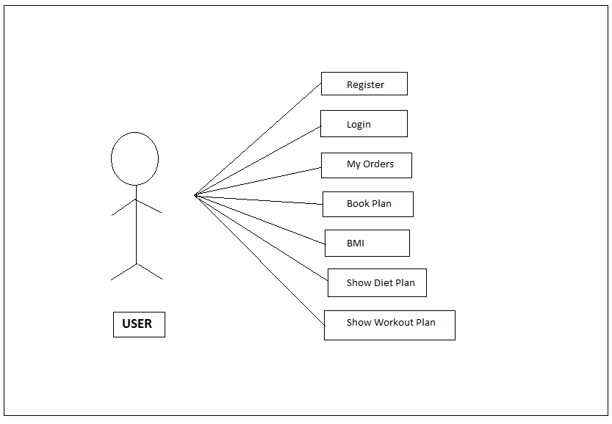

*Fig. Use case diagram for User*

1. In User use case diagram User is the Actor**.**
2. User can handle following use cases:
3. Register
4. Login
5. Check Orders
6. Book Plans
7. Check Plans
8. Check Diet Plan
9. Check Workout Plan

**Trainer :**

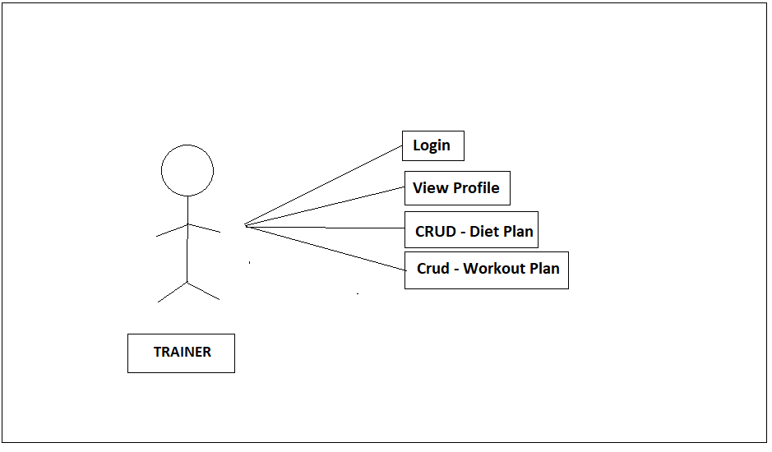

*Fig. Use case diagram for Trainer*

1. In Trainer use case diagram Trainer is the Actor.
2. Trainer can handle following use cases:
3. Login
4. View Profile
5. CRUD – Diet Plan
6. CRUD – Workout Plan

**Admin:**

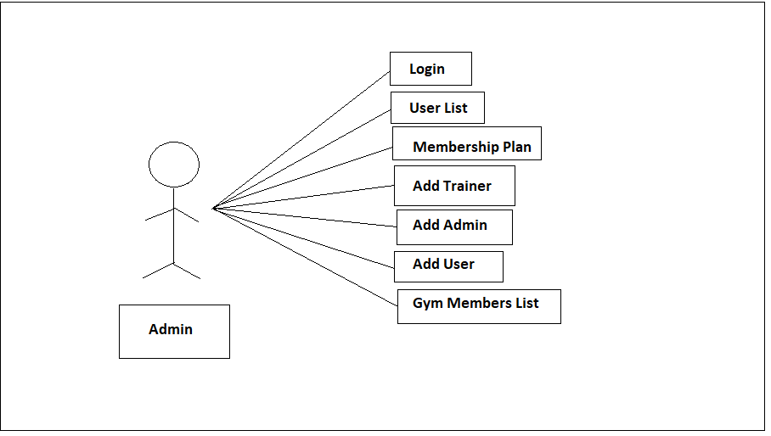

*Fig. Use case diagram for admin*

1. In Admin use case diagram Admin is the Actor.
2. Admin can handle following use cases:
3. Login
4. User List
5. Membership Plan
6. Add Trainer
7. Add Admin
8. Gym Member List